Health Care Analysis
Analysis for Optimal Patient Care

Name: Igbozuruike Confidence Ginika
Date: 01/15/2026

EXECUTIVE SUMMARY
This report analyzes 54,965 admission records to describe patient demographics, medical conditions, billing patterns, hospital admissions, length of stay, medications, doctors, test results, and monthly trends. The average recorded length of stay was 15 days, the average patient age was 52 years, and the average billing amount was $25,544.31. Arthritis had the highest number of records, with 9218, while Diabetes had the highest total billing at $236.49 million. These findings describe patterns in the dataset; they do not, on their own, prove that a treatment was effective or that a hospital was more efficient.

OBJECTIVE
This report analyzes patient trends, hospital activity, and medical insights to identify patterns that may help hospitals improve patient care, manage costs, and review service efficiency.

Exploratory Data Analysis (EDA)
- Compare the average length of stay by admission type.
- Identify the medical condition with the highest number of admissions.
- Compare total billing by medical condition and identify the three highest.
- Summarize patient records by blood group and gender.
- Identify hospitals with the highest admission counts.
- Compare the average age of patients across medical conditions.
Deep Analysis & Insights
- Identify the insurance provider with the highest total billing.
- Find the most frequently recorded medication for each medical condition.
- Identify the doctor with the highest number of patient records.
- Summarize test results overall and across medical conditions.
- Review monthly and yearly admission patterns.

DATA COLLECTION AND METHODOLOGY
The dataset contains 54,965 rows and 17 columns. The data was obtained from Dayfigurex (https://www.dayfigurexconsult.com). The admission dates range from 08 May 2019 to 07 May 2024.
For data cleaning, I checked that each field had the appropriate data type. I found the entries in the name field were not consistently formatted, so I created an additional column and used Excel’s PROPER function to standardize the names. I calculated the length of stay in a new column using Excel’s DAYS function. After removing duplicated records, I checked the and found no remaining duplicates or missing values.
Tool Used: Microsoft Excel for data cleaning, analysis, pivot summaries, and dashboard visualizations

DATA ANALYSIS
Explorative Data Analysis (EDA)
      - Average Length of Stay by Admission Type
Emergency admissions had the highest average length stay with 16 days while Elective and Urgent cases are 15 days

      - Hospitals with the Highest Number of Admissions
LLC Smith had the highest of admissions, with 44 records. Ltd Smith had 39 records, Smith Ltd and Johnson PLC were tied at 37 records each, while Smith PLC had 36 records
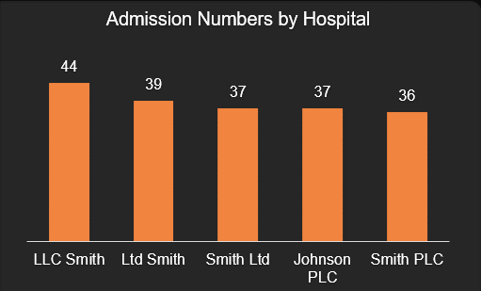

- Total Billing by Medical Condition
The three medical conditions with highest total billing were Diabetes with $236.46 million, Obesity with $236.01 million, and Arthritis with $235.17 million, respectively. These figures represent total billing across records, not average cost per patient or proof that a condition is more expensive to treat in every case.
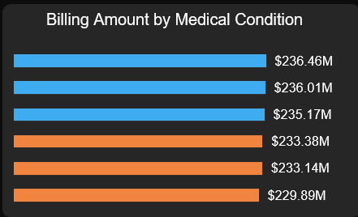

- Patient Records by Blood Group
A- was the most frequently recorded blood group with 6,898 records, while O- was the least frequent with 6,804 records. The difference between the blood group counts were relatively small.
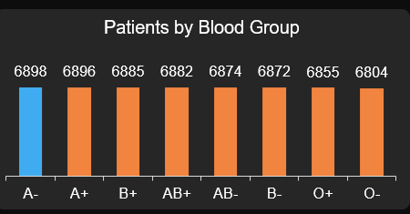

- Gender Distribution by Medical Condition
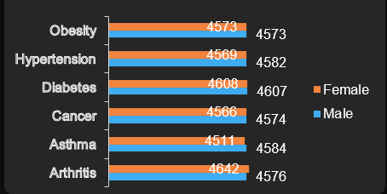
The report records 27,469 female admissions and 27,496 male admissions. Female counts were higher for Arthritis and Obesity, while male counts were slightly higher for Asthma, Cancer, Diabetes, and Hypertension.

- Number of Patients Record by Medical Condition
Arthritis had the highest number of records, with 9,218, while Asthma had the lowest, with 9,095.
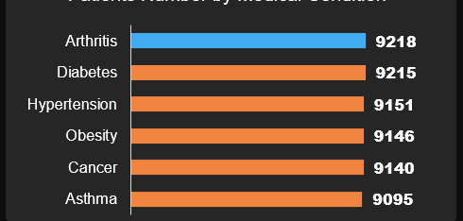

- Average Age by Medical Condition
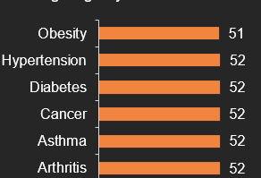
The average age was approximately 52 years for most medical conditions, while Obesity had an average age of approximately 51 years.

Deep Analysis and Insight
- Total Billing by Insurance Provider
Cigna had the highest total recorded billing at $284.33 million. This comparison is based on total billing associated with each provider, it does not establish which provider covers the most expensive individual treatments.
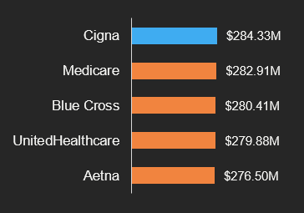

- Most Frequently Recorded Medications for the respective medical Condition were:
Obesity: Penicillin, Hypertension: Ibuprofen, Diabetes: Lipitor, Cancer: Lipitor, Asthma: Paracetamol, Arthritis: Aspirin.
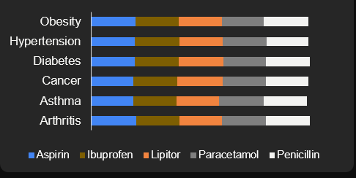

- Doctor With the Highest Number of Admissions
Dr. Michael Smith had the highest number of patient records, with 27.
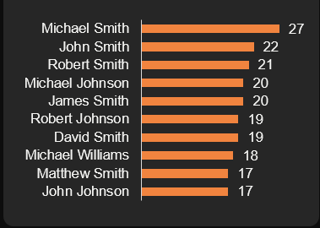

- Test Result Distribution
Abnormal was the most common test result, with 18,437 records (34%), followed by Normal, with 18,331 records (33%) and Inconclusive, with 18,198 records (33%).

Medications are Distributed Across Medication Conditions
Across medical conditions, Abnormal was the most frequent result for Arthritis, Cancer, Diabetes, and Obesity. Normal was the most frequent result for Asthma and Hypertension. The three test-result counts add up to 54,965, matching the reported total number of admission records
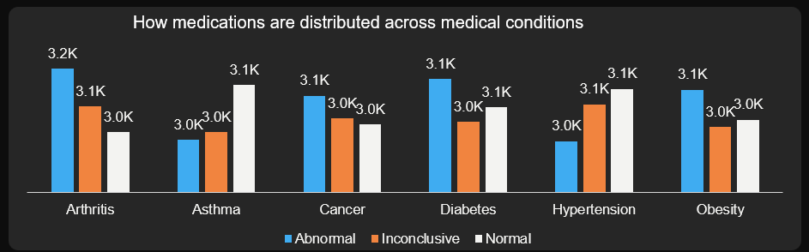

- Monthly and Yearly Admission Patterns
August had the highest monthly count, with 4,785 records, followed by July with 4,765 records. August exceeded July by 20 records.
The yearly chart covers 2019 to 2024. The dataset runs from 8 May 2019 to 7 May 2024, so 2019 and 2024 are partial years rather than complete calendar years.
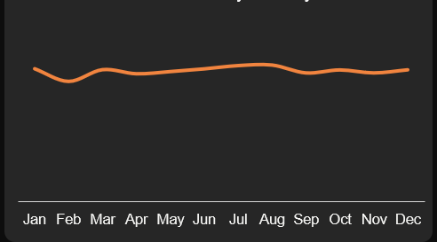

RECOMMENDATIONS
- Investigation why Emergency admissions had the longest average stays among the admission types, at approximately 16 days. Review case severity, discharge delays, and care processes before drawing conclusion.
- Compare hospitals billing amounts with patient outcomes, case complexity, and length of stay. High billing alongside a short stay does not, by itself, prove efficiency or overuse of diagnostics.
- Use billing and outcome indicators together to identify opportunities to improve care quality, support appropriate treatment, and reduce avoidable costs.
- Consider targeted prevention and patient-education initiatives for conditions such as obesity, diabetes and hypertension based on local patient needs.

CONCLUSION
The analysis shows that Arthritis had the highest number of admission records, while Diabetes, Obesity, and Arthritis recorded the three highest total billing amounts. These findings highlight the value of monitoring common medical conditions and reviewing opportunities for preventive care and chronic disease management.
Cigna had the highest total billing among the insurance providers shown. The analysis also identified differences in test-result patterns across medical conditions and a higher number of admissions in August than in July. These findings can support further investigation, but additional clinical and operational information is needed before drawing conclusions about treatment effectiveness, hospital efficiency, or prescribing practices.

